# **Report – Week 1**

**Project Title:** Campus Graph Modeling for Autonomous Navigation

**Prepared by:** vemana Hemanth babu

**Week:** 1

**1. Introduction**

The first week of the project focused on building a structured representation of the campus environment for autonomous navigation and path planning. The approach adopted was to model the campus as a **graph**, where nodes represent landmarks and waypoints, and edges represent walkable/drivable paths between them. This representation will serve as the foundation for implementing pathfinding and coverage algorithms in subsequent weeks.

## **2. Methodology**

1. **Data Collection**
   * A KML file of the campus map was parsed to extract geographic coordinates.
   * Important landmarks (blocks, gates, hostels, sports facilities, and utility points) were identified as graph nodes.
2. **Path Segmentation**
   * Polyline data from the KML file was segmented into path nodes.
   * Intermediate points along pathways were preserved to capture accurate routes.
3. **Graph Construction**
   * Each node was assigned latitude and longitude.
   * Connections (edges) between nodes were created using the extracted paths.
   * Distances between connected nodes were calculated using the geodesic formula, ensuring accurate edge weights.

## 

## 

## **3. Node Identification**

Key landmarks modeled as graph nodes include:

* **Academic Infrastructure:** Block A, Block B, Bridge
* **Accommodation & Services:** Hostel, Food Court, Rest Area
* **Entry & Security Points:** In Main Gate, Out Gate, Check Post, Flag Post
* **Sports Facilities:** Basketball Ground, Cricket Ground, Football Ground, Volleyball Ground, Tennis Court

## **4. Path Network (Edges)**

The graph edges represent campus pathways, structured as follows:

* **In–Out Path:** Detailed path from Main Gate (IN) to Out Gate with ~39 intermediate nodes.
* **Block A Path:** Loop structure covering Block A with ~5 nodes.
* **Block B Path:** Internal circulation path with ~11 nodes.
* **Food Court Path:** Short pathway loop with ~2 nodes.
* **Sports Path:** Network of edges linking cricket, football, volleyball, and basketball grounds (~8 nodes).

## 

## **5. Graph Model Summary**

* **Graph Type:** Weighted, undirected
* **Nodes (V):** ~120 (landmarks + path points)
* **Edges (E):** ~150+ (path segments with distances)
* **Purpose:** Provides a navigable model of the campus for algorithms such as BFS, Dijkstra, and A*.

## 

## **6. Week 1 Deliverables**

* Extracted coordinates of all major landmarks and path points
* Constructed campus path network with distances
* Built weighted undirected graph representation
* Prepared adjacency structure for algorithmic use
* Draft report compiled for documentation

**Appendex 1 :**

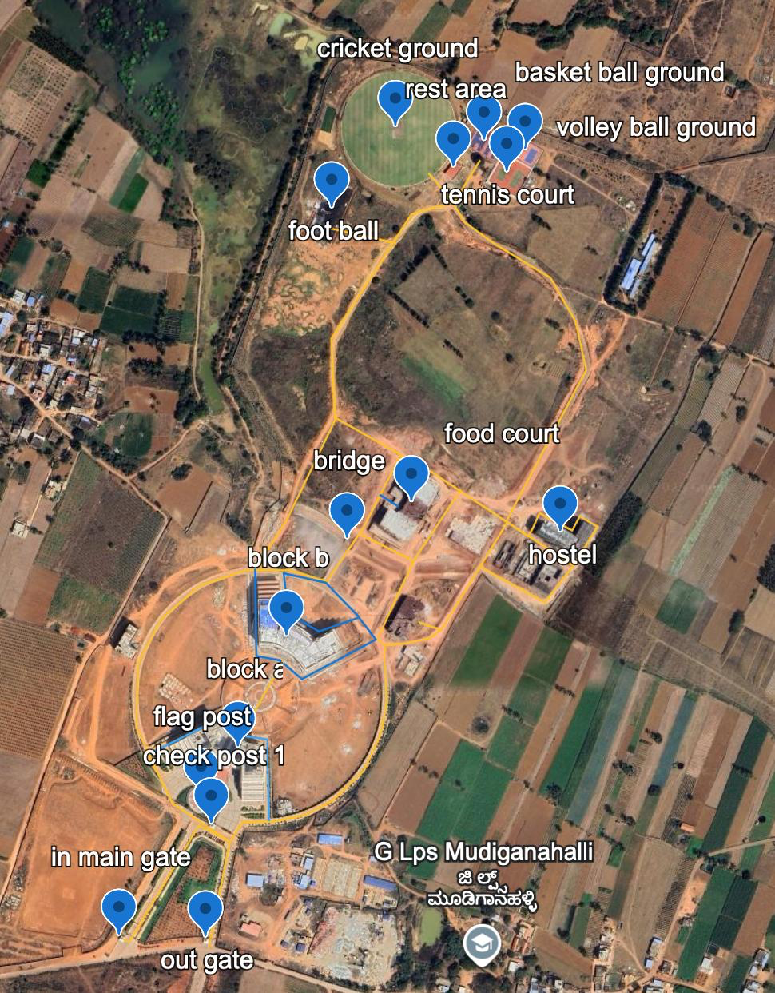

**Coordinates :**

|  |  |  |
| --- | --- | --- |
| name | lat | lon |
| basket ball ground | 13.228789 | 77.7581186 |
| block a | 13.2221815 | 77.7553608 |
| block b | 13.223385 | 77.7559033 |
| bridge | 13.2244444 | 77.7565826 |
| check post 1 | 13.2213483 | 77.7550606 |
| cricket ground | 13.2289443 | 77.7571282 |
| flag post | 13.2216676 | 77.7549481 |
| food court | 13.2248484 | 77.757305 |
| foot ball | 13.2280544 | 77.7564117 |
| hostel | 13.2245187 | 77.7589759 |
| in main gate | 13.220146 | 77.7540314 |
| out gate | 13.2201213 | 77.7549963 |
| rest area | 13.228501 | 77.7577772 |
| tennis court | 13.2284459 | 77.7583724 |
| volley ball ground | 13.2286875 | 77.7585775 |
| in out path_pt0 | 13.2201484 | 77.754067 |
| in out path_pt1 | 13.220121 | 77.7541376 |
| in out path_pt2 | 13.2213784 | 77.7549138 |
| in out path_pt3 | 13.2211974 | 77.7552602 |
| in out path_pt4 | 13.2214076 | 77.7554007 |
| in out path_pt5 | 13.2214187 | 77.7557399 |
| in out path_pt6 | 13.2214822 | 77.7560814 |
| in out path_pt7 | 13.2216374 | 77.7563951 |
| in out path_pt8 | 13.221968 | 77.7567581 |
| in out path_pt9 | 13.2223423 | 77.7569412 |
| in out path_pt10 | 13.2227245 | 77.7570238 |
| in out path_pt11 | 13.223194 | 77.7569927 |
| in out path_pt12 | 13.2233263 | 77.7570011 |
| in out path_pt13 | 13.2233432 | 77.7572192 |
| in out path_pt14 | 13.2234056 | 77.7574959 |
| in out path_pt15 | 13.2235012 | 77.7576368 |
| in out path_pt16 | 13.2246702 | 77.7583733 |
| in out path_pt17 | 13.2241933 | 77.7591179 |
| in out path_pt18 | 13.2246216 | 77.7593838 |
| in out path_pt19 | 13.2247356 | 77.7591882 |
| in out path_pt20 | 13.2245795 | 77.7591005 |
| in out path_pt21 | 13.2247285 | 77.7588102 |
| in out path_pt22 | 13.2247711 | 77.758734 |
| in out path_pt23 | 13.224605 | 77.758659 |
| in out path_pt24 | 13.2245172 | 77.7586047 |
| in out path_pt25 | 13.2246682 | 77.7583747 |
| in out path_pt26 | 13.2252401 | 77.7574904 |
| in out path_pt27 | 13.2253983 | 77.7571739 |
| in out path_pt28 | 13.2246156 | 77.7567622 |
| in out path_pt29 | 13.2240273 | 77.7563461 |
| in out path_pt30 | 13.2241483 | 77.7559245 |
| in out path_pt31 | 13.2241474 | 77.7554317 |
| in out path_pt32 | 13.2239886 | 77.7549292 |
| in out path_pt33 | 13.2236199 | 77.7544915 |
| in out path_pt34 | 13.2231404 | 77.7542347 |
| in out path_pt35 | 13.2224535 | 77.7542173 |
| in out path_pt36 | 13.2219982 | 77.7544308 |
| in out path_pt37 | 13.2216233 | 77.7546207 |
| in out path_pt38 | 13.2211942 | 77.7552608 |
| in out path_pt39 | 13.2200422 | 77.7550207 |
| block a path_pt0 | 13.2221645 | 77.7543718 |
| block a path_pt1 | 13.2225496 | 77.7551626 |
| block a path_pt2 | 13.2223644 | 77.7553294 |
| block a path_pt3 | 13.2223121 | 77.7556788 |
| block a path_pt4 | 13.2214225 | 77.7556995 |
| block b path_pt0 | 13.2241637 | 77.7555433 |
| block b path_pt1 | 13.2232182 | 77.7555571 |
| block b path_pt2 | 13.2231686 | 77.7558208 |
| block b path_pt3 | 13.2229653 | 77.7560678 |
| block b path_pt4 | 13.2233878 | 77.7568993 |
| block b path_pt5 | 13.223632 | 77.7567077 |
| block b path_pt6 | 13.223482 | 77.7562584 |
| block b path_pt7 | 13.2236783 | 77.7559143 |
| block b path_pt8 | 13.2241138 | 77.7558641 |
| block b path_pt9 | 13.2240122 | 77.7563361 |
| block b path_pt10 | 13.2236407 | 77.7567053 |
| a to b connection_pt0 | 13.2231609 | 77.7558573 |
| a to b connection_pt1 | 13.2223594 | 77.7553847 |
| a to b connection_pt2 | 13.2223376 | 77.7553857 |
| food court_pt0 | 13.2248403 | 77.7571544 |
| food court_pt1 | 13.2249696 | 77.7569428 |
| path_pt0 | 13.2233908 | 77.7569157 |
| path_pt1 | 13.2242469 | 77.7573211 |
| path_pt2 | 13.2245504 | 77.7567011 |
| path_pt0_1 | 13.2242326 | 77.7573074 |
| path_pt1_1 | 13.2250298 | 77.7578546 |
| path_pt0_2 | 13.224184 | 77.758066 |
| path_pt1_2 | 13.2237967 | 77.7587931 |
| path_pt2_1 | 13.2241919 | 77.7591154 |
| sports_pt0 | 13.2246684 | 77.7583559 |
| sports_pt1 | 13.2263325 | 77.759259 |
| sports_pt2 | 13.2268573 | 77.7591396 |
| sports_pt3 | 13.2273359 | 77.7588547 |
| sports_pt4 | 13.2277131 | 77.7582231 |
| sports_pt5 | 13.2279426 | 77.7578966 |
| sports_pt6 | 13.2281434 | 77.757768 |
| sports_pt7 | 13.2286205 | 77.7580675 |
| Untitled path_pt0 | 13.2281664 | 77.7577665 |
| Untitled path_pt1 | 13.2284814 | 77.7574913 |
| path_pt0_3 | 13.2281579 | 77.75775 |
| path_pt1_3 | 13.2280328 | 77.7573003 |
| path_pt2_2 | 13.2266746 | 77.756401 |
| path_pt3 | 13.2257888 | 77.7564432 |
| path_pt4 | 13.2246798 | 77.75589 |
| path_pt5 | 13.2243175 | 77.7556502 |
| path_pt6 | 13.2241481 | 77.7556092 |
| path_pt0_4 | 13.2253987 | 77.757196 |
| path_pt1_4 | 13.2258189 | 77.7564283 |
| path_pt0_5 | 13.2277134 | 77.7571301 |
| path_pt1_5 | 13.2278778 | 77.7563801 |
| Untitled path_pt0_1 | 13.2233201 | 77.757006 |
| Untitled path_pt1_1 | 13.2233882 | 77.7569141 |
| Untitled path_pt0_2 | 13.2234999 | 77.7576098 |
| Untitled path_pt1_2 | 13.2235801 | 77.7573776 |